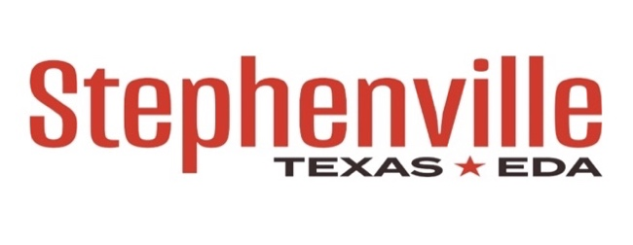
REGULAR MEETING
322 Belknap, Stephenville Texas
Friday, November14, 2025 at 12:00 Noon

- Call To Order
- Consent Agenda
- Minutes from September 18th, 2025
- Financials from September 30th, 2024

- Consider and Discuss Possible Approval for Façade Grant Applicants
- 2180 W. South Loop, South Loop Plaza, LLC

- Discussion and possible action related to the Implementation Timeline for Selected Façade Grant Applicants.

Note: The Stephenville Type B Economic Development Authority may convene into Executive Session on any matter related to any of the above agenda items for a purpose, such closed session allowed under Chapter 551, Texas Government Code.

